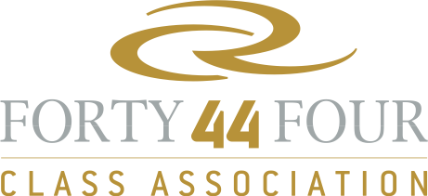
 |  |  |  |  |  | Oracle RC44 Cup Miami | RC44 World Championship Puerto Calero Islas Canarias | RC44 Valencia Cup | RC44 Copenhagen Cup | RC 44 Austria Cup | RC44 Al Maktoum Trophy
Ranking | Sail N° | Team | Name | Surname | Total
1 | USA 19 | ORACLE Racing | ELLISON | Larry | 10 | 2 | 1 | 5 | 1 | 1 | 9
2 | USA 17 | 17 | SPITHILL | James | 13 | 1 | 2 | 3 | 5 | 2 | 11
3 | NED 18 | No Way Back | HEEREMA | Pieter | 15 | 4 | 3 | 4 | 2 | 3 | 3
4 | SWE 44 | Artemis Racing |  |  | 19 | 5 | 7 | 2 | 3 | 7 | 2
5 | GBR 2041 | Team Aqua | BAKE | Chris | 23 | 9 | 8 | 1 | 4 | 9 | 1
6 | UAE 77 | Sea Dubai | DIMC |  | 28 | 11 | 4 | 8 | 7 | 4 | 5
7 | SLO 11 | Ceeref | LAH | Igor | 30 | 6 | 6 | 9 | 8 | 5 | 4
8 | RUS 007 | Katusha |  |  | 47 | 7 | 5 | 6 | 6 | 8 | 6
9 | ESP 1 | Puerto Calero | CALERO | Daniel | 38 | 8 | 11 | 7 | 9 | 6 | 8
10 | ITA 07 | Mascalzone Latino | ONORATO | Vincenzo | 46 | 3 | 9 | 11 | 12 | 12 | 11
11 | AUT 44 | AEZ | MANGOLD | Rene | 47 | 14 | 10 | 10 | 10 | 10 | 7
12 | GBR 1 | Peninsula Petroleum | BASSADONE | John | 57 | 10 | 12 | 13 | 12 | 12 | 11
13 | RUS 13 | Synergy Sailing Team | ZAVADNIKOV | Valentin | 60 | 12 | 13 | 13 | 12 | 12 | 11
14 | USA 1 | Ironbound | MURPHY | David | 61 | 13 | 15 | 13 | 12 | 12 | 11
2010 Annual Fleet Racing Ranking

