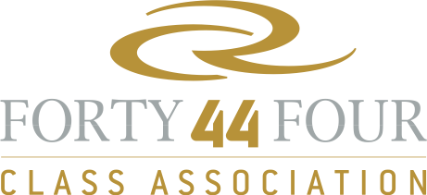
 |  |  |  |  |  | Oracle RC44 Cup Miami | RC44 World Championship Puerto Calero | RC44 Valencia Cup | RC44 Copenhagen Cup | RC 44 Austria Cup | RC44 Al Maktoum Trophy
Ranking | Sail N° | Team | Name | Surname | Total
1 | UAE 440 | Aqua | BAKE | Chris | 10 | 1 | 2 | 1 | 1 | 2 | 7
2 | SWE 44 | Artemis | TORNQVIST | Torbjorn | 12 | 2 | 2 | 2 | 3 | 7 | 3
3 | USA 19 | ORACLE Racing | ELLISON | Larry | 14 | 6 | 3 | 3 | 2 | 7 | 5
4 | UAE 77 | Sea Dubai | DIMC |  | 22 | 5 | 8 | 4 | 7 | 5 | 1
5 | NED 18 | No Way Back | HEEREMA | Pieter | 23 | 8 | 6 | 7 | 4 | 4 | 2
6 | USA 17 | 17 | SPITHILL | James | 24 | 7 | 1 | 5 | 5 | 6 | 11
7 | RUS 007 | Katusha |  |  | 30 | 9 | 4 | 6 | 9 | 3 | 8
8 | SLO 11 | Ceeref | LAH | Igor | 33 | 10 | 7 | 8 | 6 | 8 | 4
9 | ITA 07 | Mascalzone Latino | ONORATO | Vincenzo | 45 | 3 | 9 | 10 | 12 | 12 | 11
10 | ESP 1 | Puerto Calero | CALERO | Daniel | 45 | 13 | 11 | 9 | 10 | 9 | 6
11 | AUT 44 | AEZ | MANGOLD | Rene | 48 | 14 | 10 | 11 | 8 | 10 | 9
12 | RUS 13 | Synergy Sailing Team | ZAVADNIKOV | Valentin | 52 | 4 | 13 | 13 | 12 | 12 | 11
13 | GBR 1 | Peninsula Petroleum | BASSADONE | John | 59 | 12 | 12 | 13 | 12 | 12 | 11
14 | USA 1 | Ironbound | MURPHY | David | 59 | 11 | 15 | 13 | 12 | 12 | 11
2010 Annual Match Racing Ranking

